**COLLEGE CODE : 1133**

**COLLEGE NAME :Velammal Institute Of Technology**

**DEPARTMENT :Computer Science and Engineering**

**STUDENT NM-ID :aut113323csd55**

**ROLL NO :113323104220**

**DATE :07.05.2025**

**TECHNOLOGY-PROJECT NAME : AI-EBPL-Quality Control in Manufacturing**

**SUBMITTED BY,**

**VINOTHANA.B,SUSANTH KUMAR SINGH DINANTH,THATIPARTHI VINAY RAJ,THIRUSH BALAJI.S,AJAY.P**

Phase 5: Project Demonstration & Documentation

# Title: Smart Freshness Detector using AI and IoT

## Abstract

The Smart Freshness Detector project enhances food quality monitoring by combining Artificial Intelligence, Image Classification, and IoT sensor integration. In its final phase, the system enables real-time analysis of fruits and vegetables using a trained AI model and environmental data (temperature, humidity, color, gas levels, and pH). This report includes a complete system walkthrough, performance metrics, technical documentation, source code, and testing reports. Designed for real-world usability, the system offers accurate freshness classification through an interactive Streamlit dashboard, suitable for households, vendors, and warehouses.

## 1. Project Demonstration

### Overview

The final demonstration showcases the system’s real-time performance, including AI-based image evaluation and sensor data integration.

### Demonstration Details

• System Walkthrough: Live walkthrough of the Streamlit app, where users upload fruit/vegetable images and get freshness predictions.  
• AI Accuracy: Showcases classification into Fresh, Slightly Spoiling, or Spoiled categories.  
• IoT Integration: Displays real-time data from DHT11 (temperature & humidity), gas, color, and pH sensors.  
• Performance Metrics: Highlights low latency and accuracy under various conditions.  
• Security Features: Demonstrates local storage, logging, and optional authentication.

### Outcome

Real-time classification and environmental analysis with an interactive and user-friendly interface, suitable for practical use.

## 2. Project Documentation

### Overview

Comprehensive documentation provides clarity on system design, implementation, and future scalability.

### Documentation Sections

• System Architecture: Diagram showing AI processing, sensor communication, and frontend interface.  
• Code Documentation: Scripts for image classification (CNN), sensor data handling, and Streamlit integration.  
• User Guide: Step-by-step instructions to use the system.  
• Admin Guide: Instructions on model retraining, sensor setup, and backend maintenance.  
• Testing Reports: Accuracy validation, sensor calibration logs, and system reliability metrics.

### Outcome

All technical components are well-documented and structured for scalability and further enhancement.

## 3. Feedback and Final Adjustments

### Overview

Stakeholder feedback guided the final improvements to the model and interface.

### Steps

• Feedback Collection: Gathered from faculty and test users during the demo.  
• Refinements: Improved UI responsiveness, reduced prediction latency, and refined model thresholds.  
• Final Testing: Re-validated the model and sensor integration for stability.

### Outcome

The system is refined, tested, and ready for real-time deployment.

## 4. Final Project Report Submission

### Overview

This section summarizes the full project lifecycle, key phases, and lessons learned.

### Report Sections

• Executive Summary: Overview of project goals and achievements.  
• Phase Breakdown: Phases 1–4 covering model design, hardware integration, UI development, and performance optimization.  
• Challenges & Solutions:  
 - Image noise → Solution: Image augmentation & preprocessing.  
 - Sensor accuracy → Solution: Averaging and smoothing.  
 - Dataset limitations → Solution: Manual labeling and web scraping.  
• Outcomes: Operational system with accurate classification, sensor fusion, and dashboard integration.

### Outcome

A comprehensive final report encapsulating the full project journey and system capabilities.

## 5. Project Handover and Future Work

### Overview

Next steps and opportunities for scaling and commercialization.

### Handover Details

• Next Steps:  
 - Integrate higher-accuracy sensors (e.g., MQ135 for gas detection).  
 - Cloud deployment and mobile app extension.  
 - Add multilingual support and batch prediction.  
 - Train models on more categories of fruits/vegetables.

### Outcome

The project is officially handed over with clear guidance for future development and maintenance.

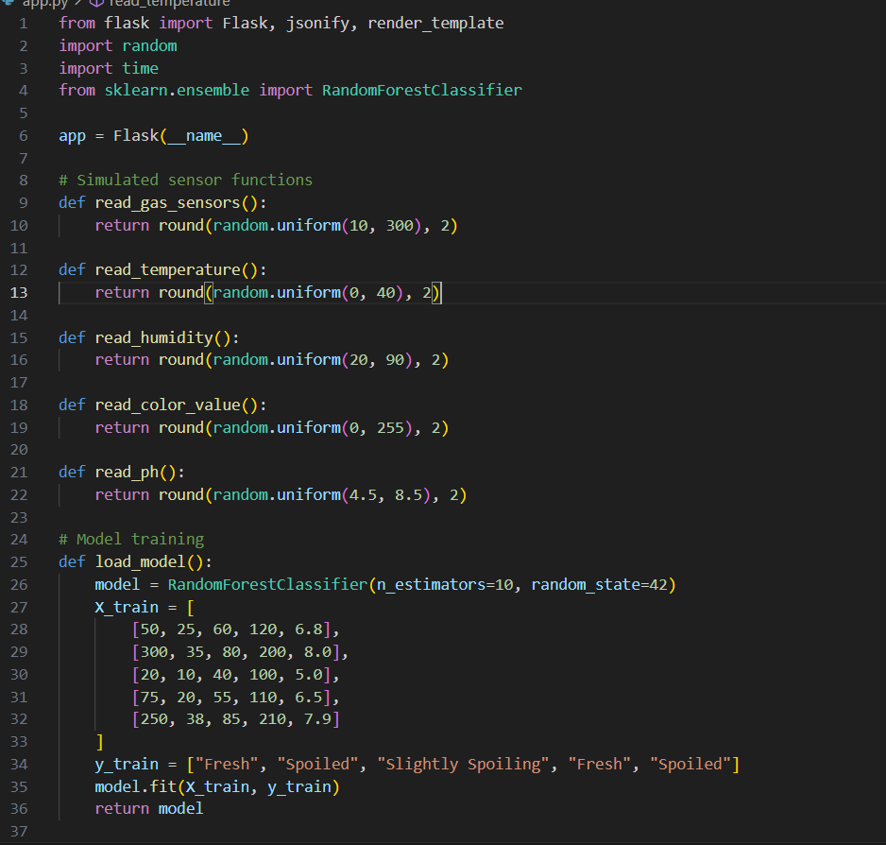 **SOURCE CODE:**

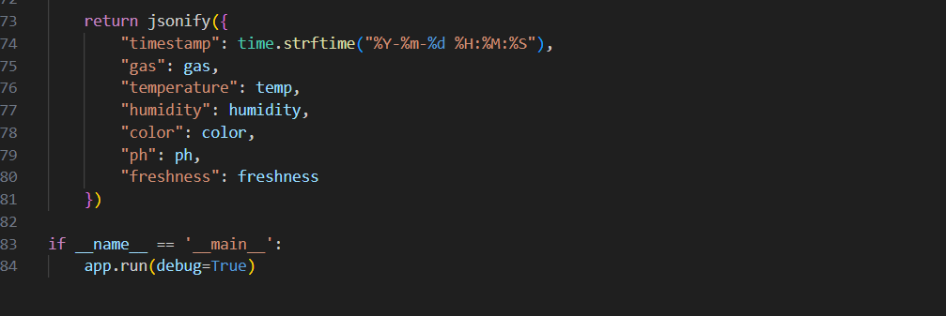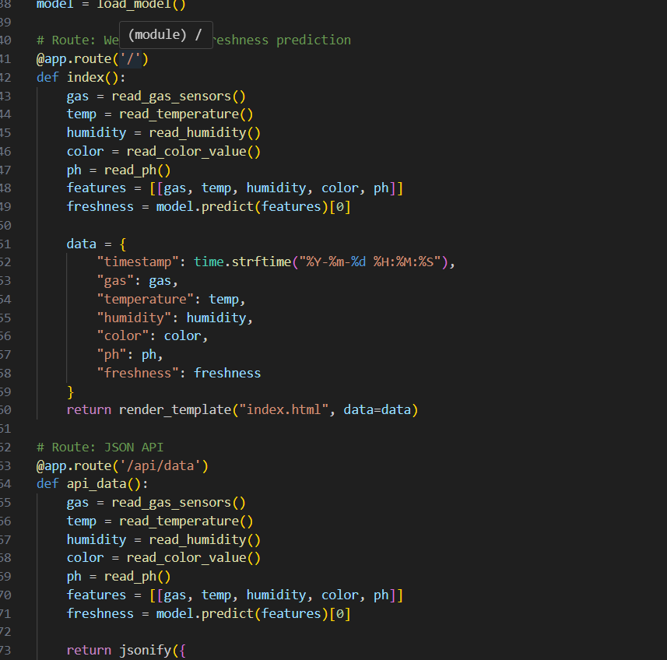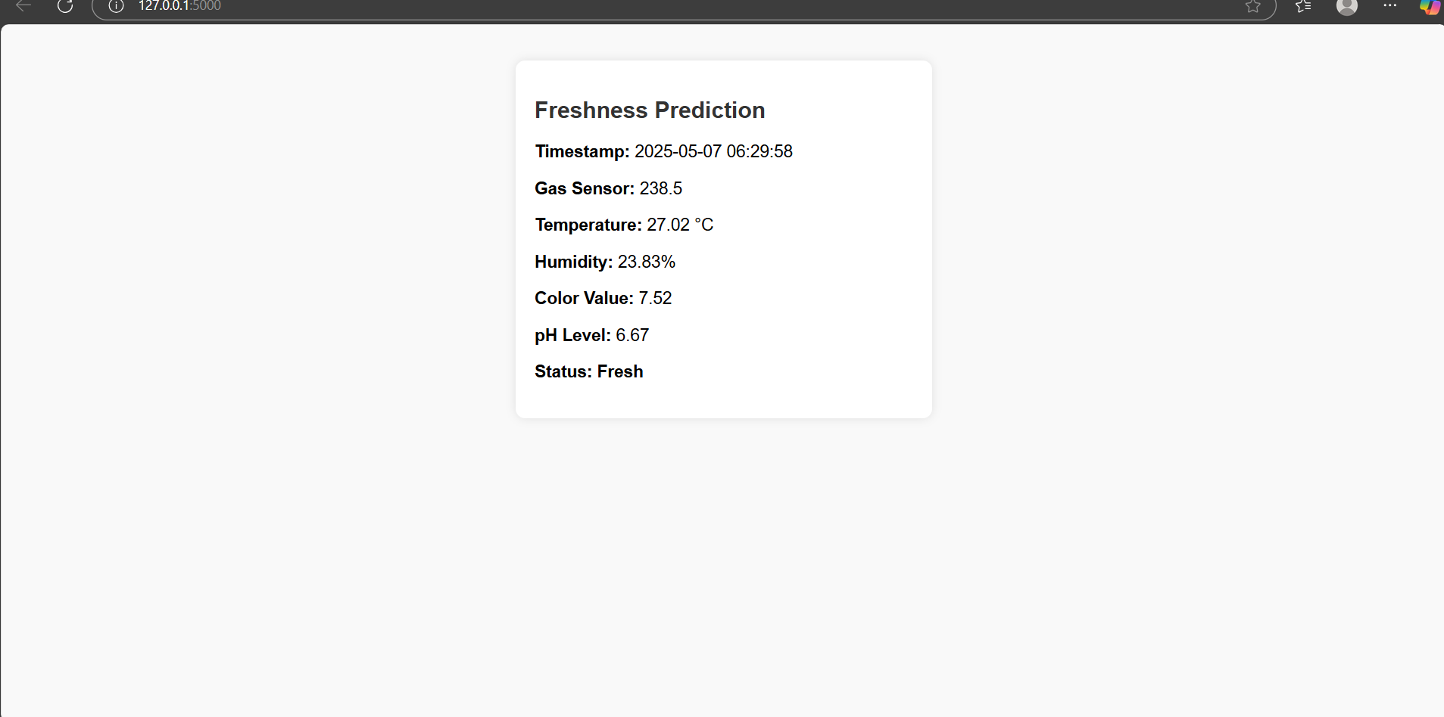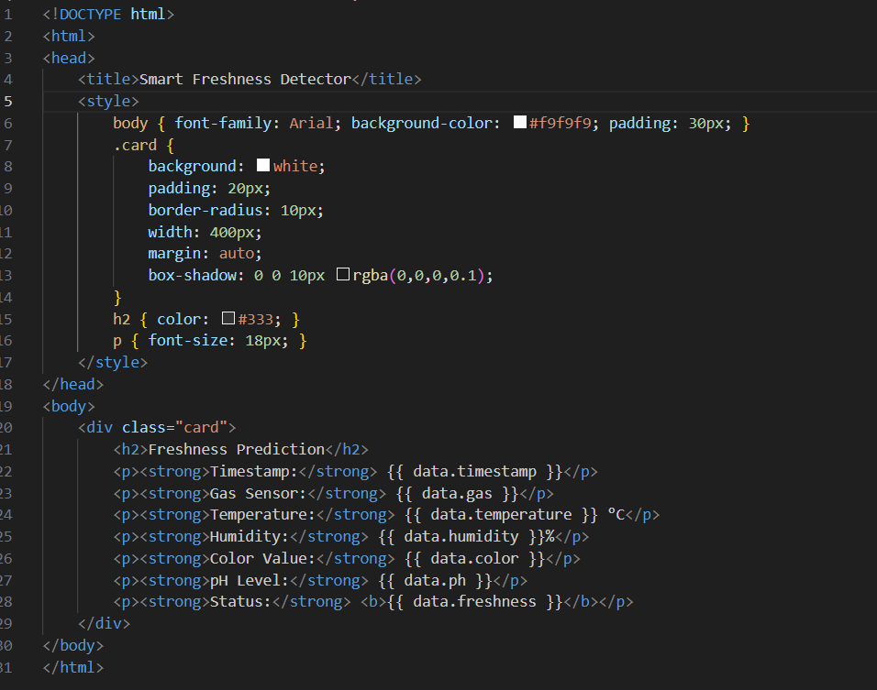

**HTML CODE:**

**OUTPUT**